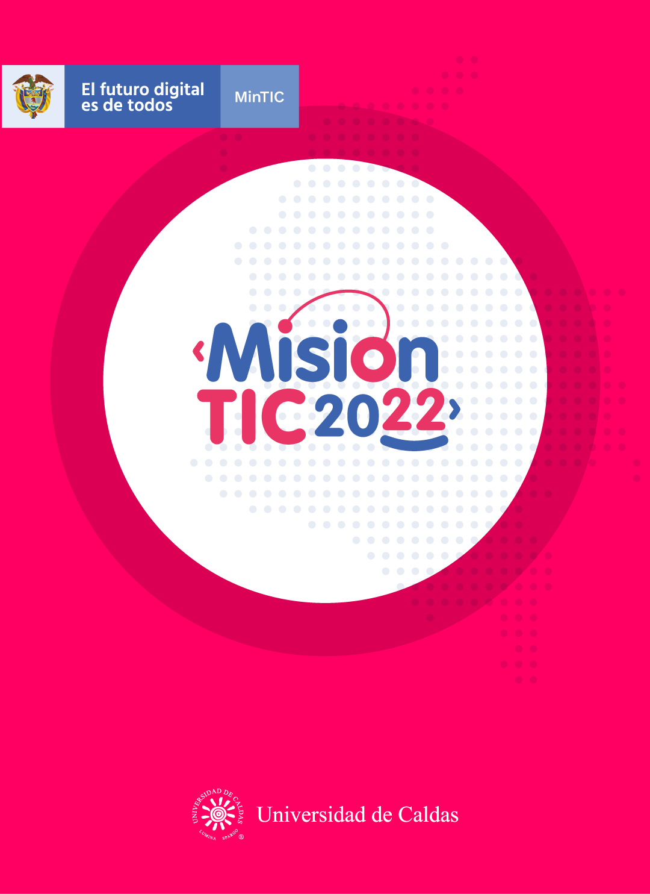

**WORKSHEETS**

**Worksheet 3.1**

**Algorithms**

1. What are some examples of *social networks*? Facebook, Instagram
2. What are some examples of a cell phone *features*? memory, Camera
3. What are you *proficient* in? language programming java
4. How do you *unlock* your cellphone? Code or password
5. What are the *broad* terms for these groups of words?

*Example: rose, orchid, lily => flowers*

* + apple, orange, banana => fruit
  + dog, cat, hamster => pets
  + cell phone, computer, tablet => computing devices

1. What *file* types do you know? PDF, PNG, JPG, DOCX.
2. Do you *share* your photos and videos on social media? Why (not)?

Only to a group friend I do not publish

1. Describe the job of a programmer:
   * Do they work in groups or alone? use both ways
   * Do they work in the office or in the street? Where is the internet
   * What do they use for work? App, servers, database
2. Is the *layout* on the English and Spanish keyboard the same or different?

Different in presentation

**Answers:**

**WORKSHEET 3.2**

**Reading strategy: Graphic organizers**

<https://www.verywellfamily.com/examples-of-graphic-organizers-2162277>

**Write some example of graphic organizers**

sequential, cause effect, hierarchical __________________________

_____________________________________________________________

**Reading**

**Algorithms: introduction**

***“Algorithms: a common language for nature, human, and computer. ” — Avi Wigderson***

What is an algorithm? Algorithm can be defined as a method for solving a problem. Some people think that it is something new, but the study of algorithms dates at least to Euclid – 300 BC! It was formalized by Church and Alan Turing in 1930s and developed more in the 20th century. It is interesting that some important algorithms were discovered by university students and not by expert programmers!

The impact of algorithms is broad and far-reaching. First, the Internet is full of them, for example, the web search, packet routing, and distributed file sharing. Second, the world of biology also works with algorithms: think of human genome project and protein folding. In the 20th century, algorithms contributed to the development of computers with the circuit layout, file system, compilers and many other things. Consequently, computer graphics appeared and introduced movies, video games and virtual reality in our lives. In the 21st century, algorithms have been used for different social networks features like recommendations, news feeds, advertisements, and so on.

Did you know that voting machines also use algorithms to count the votes in elections? So they are even used in politics!

So why should we study algorithms? They can help us solve problems that cannot have other solutions. If you want to stimulate your intellect and become a proficient programmer, it is also a good idea to study algorithms. Additionally, they may unlock the secrets of life and of the universe. Finally, computational models are replacing math models in scientific inquiry and will become more and more important in the future.

*Adapted from:*

*Coursera, Algorithms Part I*

**WORKSHEET 3.3**

**EVALUATION**

* **Answer these True/False questions about the text.**

1. The study of algorithms appeared in the 20th century. False _____

The idea was formed in 1930 by Alan Turing

1. Algorithms are only used in programming. False______

Algorithms are not only used in programming. We even use in everyday life

1. University students can discover algorithms. _True____
2. Recommendations on social networks are results of algorithms. _True__
3. Math models are more important today than computational models. False

By Advance of models computational

**WORKSHEET 3.4**

**SELF-EVALUATION**

1. Los organizadores gráficos me ayudan a organizar la información que leo

Yes No Maybe

1. Los organizadores gráficos me ayudan a visualizar la información

Yes No Maybe

1. Entiendo qué son los algoritmos y cómo son

Yes No Maybe